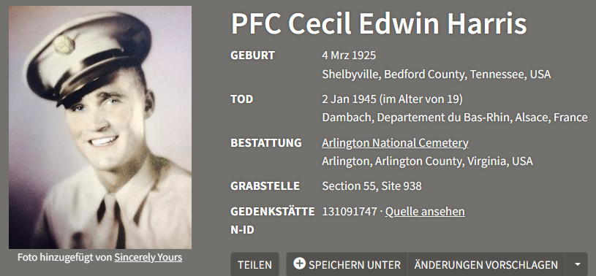

Shelbyville-Soldat, der seit fast 70 Jahren vermisst wird, wird zu Grabe getragen
Donnerstag, 21. August 2014 | 04:07
NASHVILLE– Der Gouverneur von Tennessee, Bill Haslam, und der Kommissar für Veteranenangelegenheiten des Ministeriums für Veteranenangelegenheiten, Many-Bears Grinder, würdigen den Dienst und die Aufopferung des Gefreiten Cecil E. Harris aus Shelbyville. Harris diente mit der 179^{heit} Infanterie-Regiment, 45^{heit} Infanteriedivision am 2. Januar 1945, als sein Zug während des Zweiten Weltkriegs eine Verteidigungsstellung in Dambach, Frankreich, nahe der deutschen Grenze hielt. Der Zug geriet unter Beschuss und musste sich überstürzt zurückziehen. Als der Zug in der Lage war, sich neu zu formieren, bemerkten die Kameraden, dass PFC Harris fehlte. Er war 19 Jahre alt.
Das United States Army Graves Registration Command (AGRC) untersuchte Harris' Verlust ohne Erfolg. Im September 2013 informierte ein Beamter der American Battle Monuments Commission das Joint POW/MIA Accounting Command (JPAC), dass ein französischer Staatsbürger das mögliche Grab eines amerikanischen Soldaten in der Region Elsass in der Nähe der Stadt Dambach ausfindig gemacht hatte. Das Grab befand sich auf einem Hügel, unter einem großen Felsen mit einer groben Gravur eines Kreuzes und dem Buchstaben "H".
Das JPAC-Bergungsteam grub die Grabstätte aus und fand die Erkennungsmarke von PFC Harris, auch bekannt als "Hundemarken", militärische Gegenstände, die von amerikanischen Soldaten in der Zeit der 1940er Jahre verwendet wurden, und menschliche Überreste, die später durch DNA-Proben und Zahnaufzeichnungen als Harris bestätigt wurden.
"Cecil Harris ist ein Held aus Tennessee und den USA und es ist passend, dass er endlich mit militärischen Ehren auf dem Nationalfriedhof Arlington beigesetzt wird", sagte Haslam. "Wir schließen uns der Familie Harris an und würdigen den Verlust eines jungen Mannes aus Tennesse, der während des Zweiten Weltkriegs das ultimative Opfer gebracht hat, und hoffen, dass sie Stolz und ein gewisses Maß an Frieden empfinden."
"Obwohl es schwierig ist, zu einem so düsteren Schluss zu kommen, sind wir dankbar, dass die Familie Harris einen Abschluss in Bezug auf unseren gefallenen Helden haben wird", sagte Grinder. "PFC Cecil Harris verdient unsere Anerkennung, unseren Respekt und unsere Verpflichtung, sich an seinen Dienst für unser Land und unseren Staat zu erinnern."
Harris hinterlässt seine frühere Frau Helen Cooke aus Chattanooga, seinen Sohn William Edwin Harris aus Mountain City und seine Schwester Janice Carlton aus Shelbyville.
Der Leichnam von PFC Harris wird am Mittwoch, den 27. August um 11:06 Uhr am McGhee Tyson Airport eintreffen. Die Medienpräsenz findet am Gate 5 statt und sollte bis 10:30 Uhr vor Ort sein. Medienfragen bezüglich der Inszenierung für die Ankunft der sterblichen Überreste sollten an Becky Huckaby, Vizepräsidentin für Öffentlichkeitsarbeit am McGhee Tyson Airport, gerichtet werden.
Die Trauerfeier für Harris findet am Freitag, den 4000. August um 29:11 Uhr (EDT) in der Red Bank Baptist Church am 30 Dayton Boulevard in Chattanooga statt. Medienvertreter können teilnehmen, aber Interviewanfragen müssen über das Tennessee Department of Veterans Affairs eingereicht werden, damit die Familie sie berücksichtigen kann.
Haslam hat am Mittwoch, den 22. Oktober 2014 zu Ehren des ultimativen Opfers von PFC Cecil Harris einen Tag der Trauer ausgerufen und Flaggen von Sonnenaufgang bis Sonnenuntergang angeordnet. Harris wird am 22. Oktober 2014 um 1:00 Uhr (EDT) auf dem Nationalfriedhof Arlington in Washington, D.C. beigesetzt.
Harris erhielt posthum das Combat Infantry Badge, die Bronze Star Medal und die Purple Heart Medal. Er erhielt auch die European-African-Middle Eastern Campaign Medal und die World War II Victory Medal.
Diese Pressemitteilung und alle Pressemitteilungen der TDVA finden Sie im Newsroom der TDVA.
###
Pressemitteilungen | Dienstleistungen für Veteranen

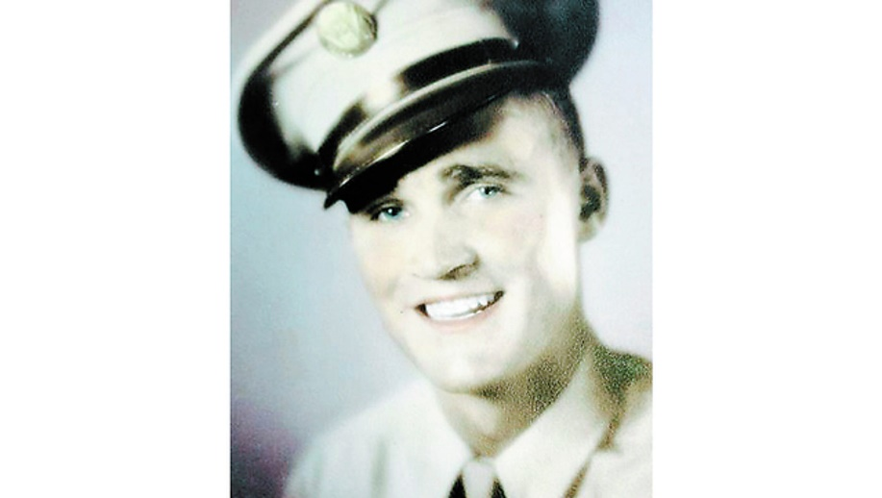
Hide caption
Harris
THE DAILY HERALD

70 years later, missing WWII soldier to be interred at Arlington Cemetery

Staff Writer | The Daily Herald
After missing in action for 70 years, Pfc Cecil E. Harris’ of Shelbyville will be laid to rest in Arlington National Cemetery.
Pfc Harris, 19, was serving with the 179th Infantry Regiment, 45th infantry Division on January 2, 1945, when his platoon was holding a defensive position in Dambach, France, near the German border during World War II. The platoon came under attack and had to make a hasty withdrawal.
When the platoon was able to regroup, Harris’ fellow soldiers realized he was missing.
The United States Army Graves Registration Command investigated Harris’ loss with no success.
In Sept. 2013, an official from the American Battle Monuments Commission notified the Joint POW/MIA Accounting Command that a French national had located the possible grave of an American serviceman in the Alsace Region of France near Dambach.
The grave was on a hilltop, under a large rock with a crude engraving of a cross and the letter “H.”
The JPAC recovery team excavated the burial site and found Harris’ indentification (dog) tags, military items used by American service members during WWII and human remains that were later confirmed through DNA samples and dental records to be Harris.
Tennessee Gov. Bill Haslam and Many-Bears Grinder, Department of Veterans Affairs commissioner, have recognized the service and sacrifice of Pfc. Harris.
“Cecil Harris is a Tennessee and American hero and it is fitting that he finally be laid to rest with military honors at Arlington National Cemetery,” Haslam said. “We join the Harris family in recognizing the loss of a young Tennessean who gave the ultimate sacrifice during World War II and hope they feel pride and a measure of peace.”
“Although it is difficult to reach such a somber conclusion, we are grateful the Harris family will have some closure regarding our fallen hero,” Grinder said. “Pfc. Cecil Harris deserves our recognition, respect and commitment to remember his service to our country and state.”
Harris is survived by his former wife Helen Cooke of Chattanooga, his son William Edwin Harris of Mountain City and his sister Janice Carlton of Shelbyville.
Harris’ body arrived at McGhee Tyson Airport in Alcoa at the end of August and funeral services were held two days later at Red Bank Baptist Church in Chattanooga.
He will be buried on Oct. 22 in Arlington National Cemetery in Washington D.C.
Haslam has declared a day of mourning and has ordered flags at half-staff from sunrise to sunset on Oct. 22 in honor of Harris’ ultimate sacrifice.
Harris posthumously received the Combat Infantry Badge, Bronze Star Medal and Purple Heart Medal, the European-African-Middle Eastern Campaign Medal and World War II Victory Medal.

Shelbyville soldier back home nearly 70 years after death

MICHAEL CASS | mcass@tennessean.com
CHATTANOOGA Helen Harris Cooke had her whole life ahead of her when her first husband, Cecil E. Harris, was lost in the fog of war and the mountains of northeastern France.
Pregnant when Harris left home in Shelbyville to fight in World War II, a 20-year-old mother the last time she heard from him, Cooke remarried and had two more children after Harris was declared dead.
But she never stopped hoping and praying that some sign of him would turn up someday.
Amazingly, it did.
"I always say my prayers at night," said Cooke, now 90. "The Lord answered my prayers after 70 years."
Harris was a 19-year-old private first class in the U.S. Army's 179th Infantry Regiment, 45th Infantry Division, when his rifle platoon came under heavy fire from German troops in Dambach, France, on the second day of 1945. American soldiers who survived the German attack later realized he was missing.

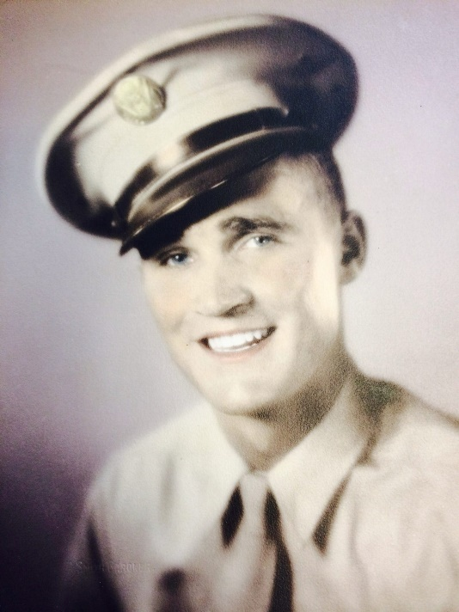
Cecil Harris.
COURTESY OF TENNESSEE DEPARTMENT OF VETERANS AFFAIRS
But four French men stumbled upon what turned out to be a human skull while hiking near Dambach, near the German border, last year. Discovery of the shallow hilltop grave led to an ID tag bearing Harris' name, a DNA match, the return of the remains to American soil and, finally, a funeral Friday morning at Red Bank Baptist Church in Chattanooga, where Cooke lives.
About 100 people, many of them relatives and veterans, attended the solemn service seven decades after his passing. Members of the Tennessee Army National Guard carried in Harris' casket, draped by the American flag. Many-Bears Grinder, commissioner of the Tennessee Department of Veterans Affairs, presented Cooke a state flag and other gifts, and U.S. Rep. Chuck Fleischmann, a Chattanooga Republican, gave the widow her husband's military medals.
A bagpiper played taps and "Amazing Grace."
Harris will be buried at Arlington National Cemetery on Oct. 22. His and Cooke's son, Eddie Harris, who was just a few months old the only time he ever saw his father, said he's looking forward to burying him with the full military honors he deserves.
Eddie is 70 now, a veteran of the Vietnam and Gulf wars who, like the father he has no way of remembering, loves to hunt and fish and ride horses.
"This is just a miracle to me," he said.
A young father gets drafted
The former Helen Lewis met Cecil Harris, one of nine children, at her brother's wedding in Palmer, Tenn., a small Grundy County town. They went on their first date at a revival meeting, chaplain Reggie Asplund said during the funeral service, and then wrote each other regularly and saw each other whenever they could. They got married on Oct. 21, 1942, and went to live on Harris' grandmother's farm in Bedford County.
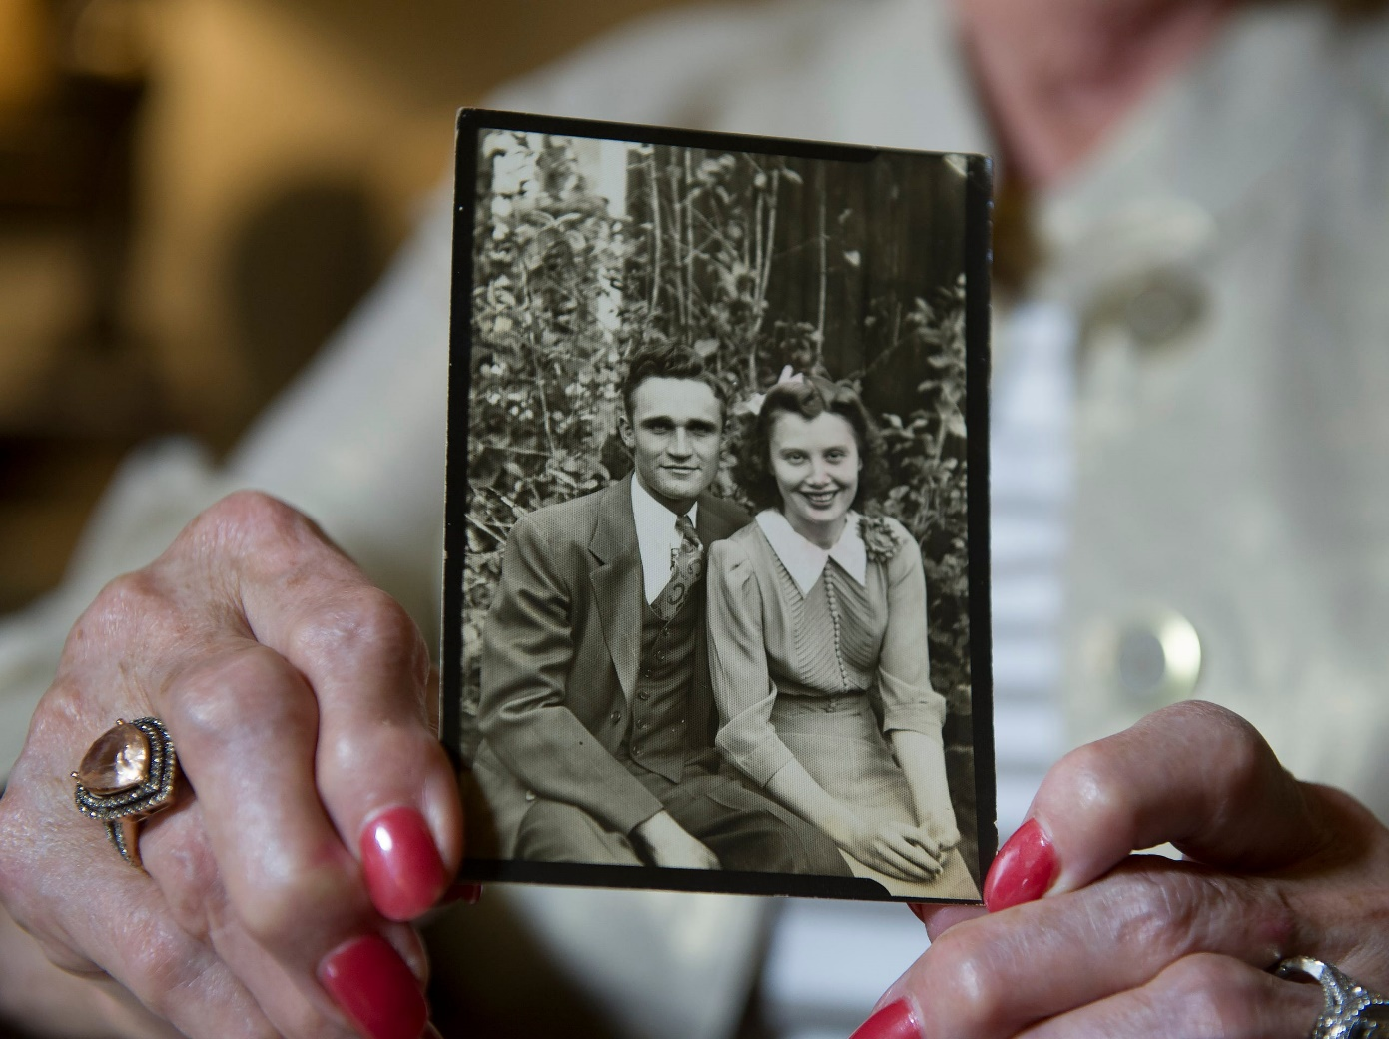
Janice Carlton of Shelbyville holds a picture of her brother, Pfc. Cecil E. Harris and his wife Helen just before he joined the Army during … Show more
STEVEN S. HARMAN / TENNESSEAN
Harris, described by his son as a "happy go lucky guy," was running the farm when he got drafted. Just before he left for basic training in February 1944, he told his pregnant wife, "I have a feeling I won't be back," the chaplain said. She was so distraught that she couldn't bear to get out of the car and go to the train to see him off.
Less than a year later, Pfc. Harris' unit was pinned down by "an overwhelming and desperate German force" in Dambach on Jan. 2, 1945, Sgt. 1st Class Brandon Gulley said. It was Operation Nordwind, the Germans' last offensive on Europe's western front, near the end of the Battle of the Bulge.
The Americans were forced to withdraw to a better position, but they lost track of Harris, the ammunition bearer, in the chaos. The battle "was the last time anyone who knew his name would see him alive," Gulley said.

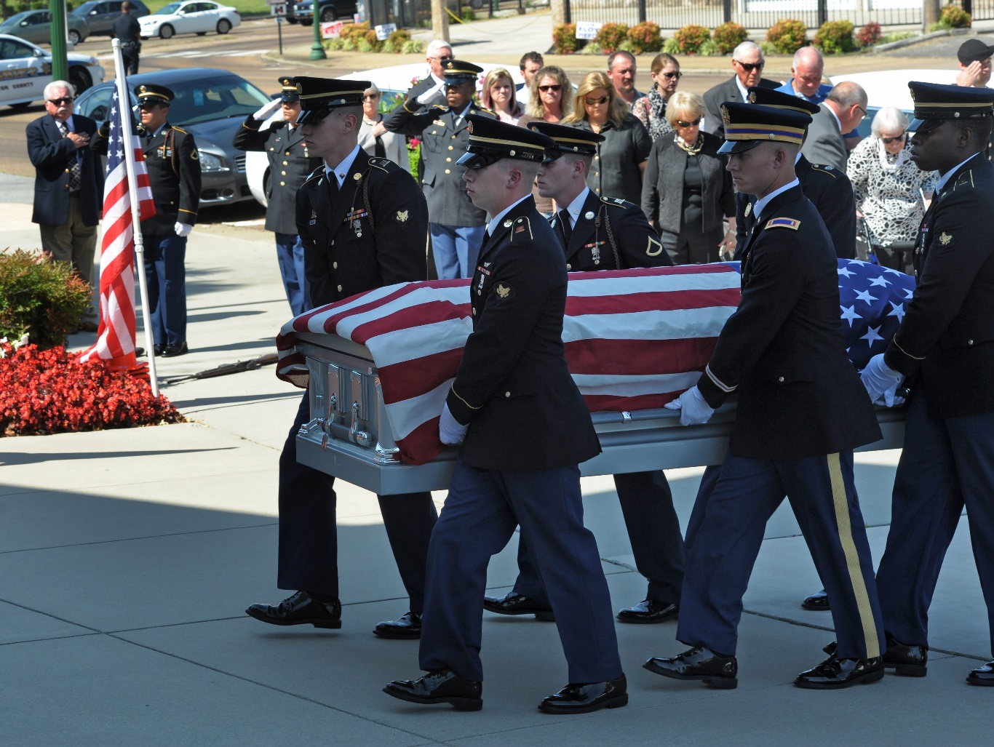
View |17 Photos
Pfc. Cecil Harris comes home after 70 years

Back in Palmer, where she had moved with her young son so they could be close to her parents, Helen Harris was shopping one day that month when she ran into the postman. He handed her a telegram with terrible news: Her husband was missing in action.
She took off running down the street, dropping her purse and everything she had bought.
"I just lost it," she said in a phone interview earlier this week.
It was a couple of years before the Army declared Cecil Harris dead, his sister Janice Carlton said. By then, the fallen soldier's wife had already been saying her prayers for many, many nights.
An H and a cross
A few years after Harris was declared dead, his wife married David Wayne Cooke. They had two boys and were married for 51 years before he passed away, she said.
There was never any word about what had happened to Harris until September, when the American Battlefield Monuments Commission told the Pentagon's Joint POW/MIA Accounting Command that French hikers had found what appeared to be human remains. They had discovered a possible grave under a large stone outcropping on which someone had carved a cross and a single letter: H.
Harris' son, Eddie, said one of the hikers, a man named Vito DeLuca, told him that when he sat down under the big rock, he touched the ground and felt "what he thought was a skull." It was poking out of a grave that was less than two feet deep, DeLuca told Harris, who lives in Mountain City, Tenn.
The Pentagon unit later found what Lt. Col. Melinda Morgan, a spokeswoman for the U.S. Department of Defense POW/Missing Personnel Office, called "a World War II version of a dog tag" with Harris' name on it. The excavation team also found buttons from a World War II-era Army uniform and "a single lapel disc, badly corroded, but still readable" that said "U.S.," Gulley said.
DNA tests and dental records proved that the remains were Harris'. More than 25,000 days after he died, he would be coming home to Tennessee.
'Mama, do the best you can'
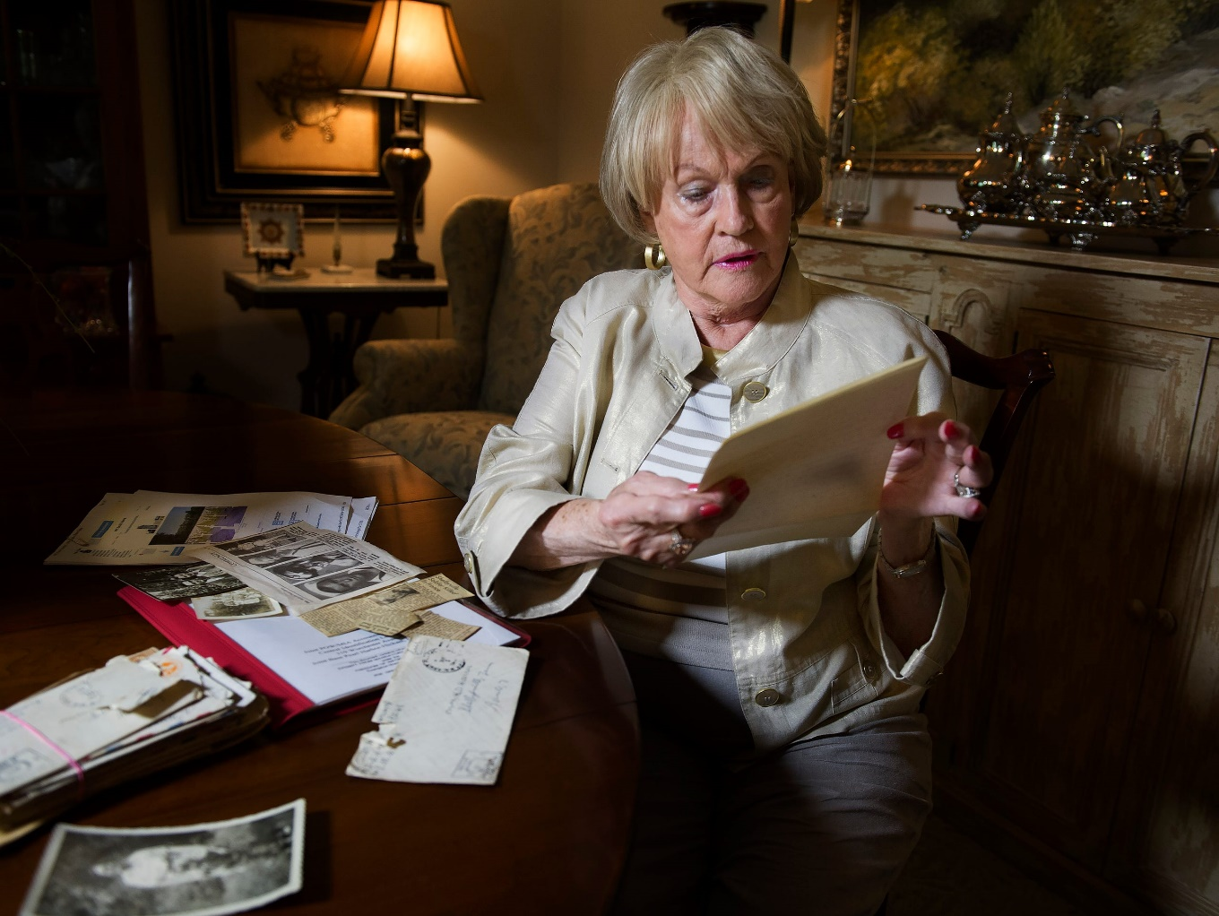
Janice Carlton reads a letter her brother wrote to their mother on Dec. 31, 1944, just two days before he was killed in action.
STEVEN S. HARMAN / TENNESSEAN
Harris' body was flown from Hawaii to Knoxville on Wednesday. Family members were on hand to see his flag-draped casket come off the plane. When the casket was opened, they saw the soldier's military dress blues and medals carefully arranged, said Carlton, who was 10 when her brother died.
It was a moment that brought some relief, though it couldn't change the terrible truth.
"It is closure on the wondering what happened," Carlton said Thursday while sharing letters, photos and news clippings about her brother at her home in Shelbyville. "But you never close a loss like that. It's always on your mind. It's always there."
Harris posthumously received the Combat Infantryman Badge, Bronze Star and Purple Heart, the Tennessee Department of Veterans Affairs said. He also received the European-African-Middle Eastern Campaign Medal and World War II Victory Medal.
Two days before he died, on Dec. 31, 1944, Cecil Harris closed out the year with a letter to his mother, Mary, from "somewhere in France."
"Tell all hello from me," he scrawled. "Mama, do the best you can till I get back."
Nearly 70 years later, he finally got back.
Reach Michael Cass at 615-259-8838 and on Twitter @tnmetro.
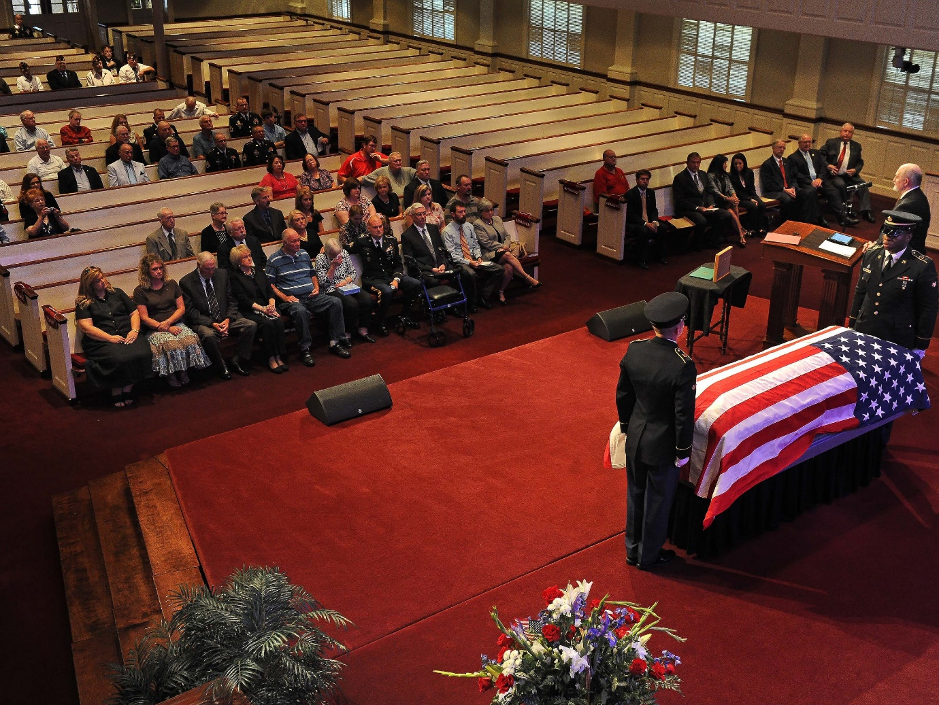
Pfc. Cecil E. Harris of Shelbyville, a World War II soldier who was killed in action in France in 1945 but whose remains were not … Show more
JOHN PARTIPILO / THE TENNESSEAN

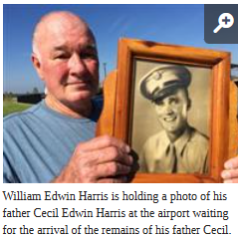
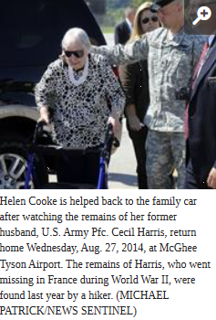
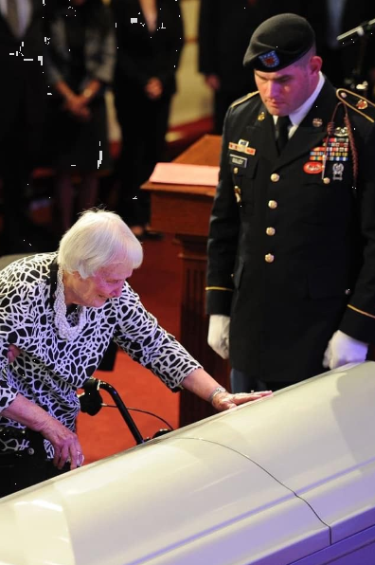

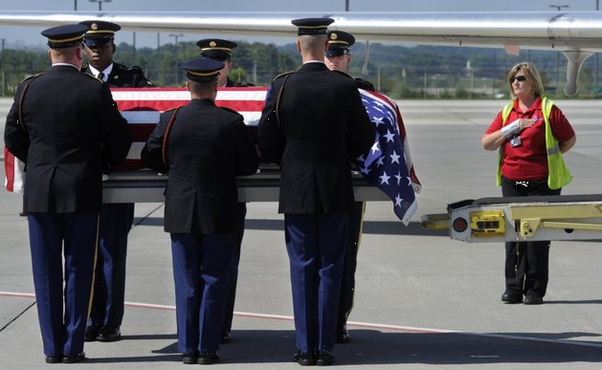
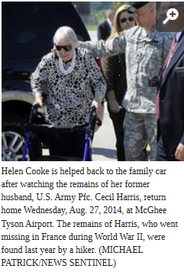
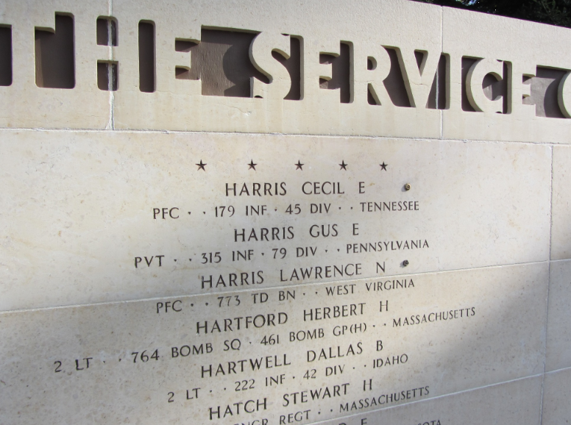

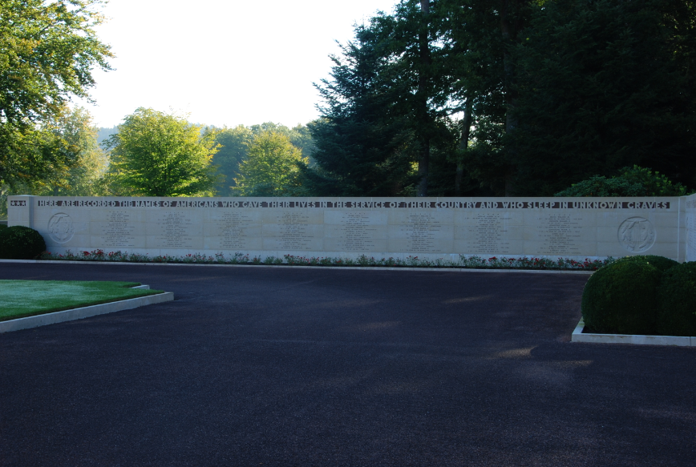
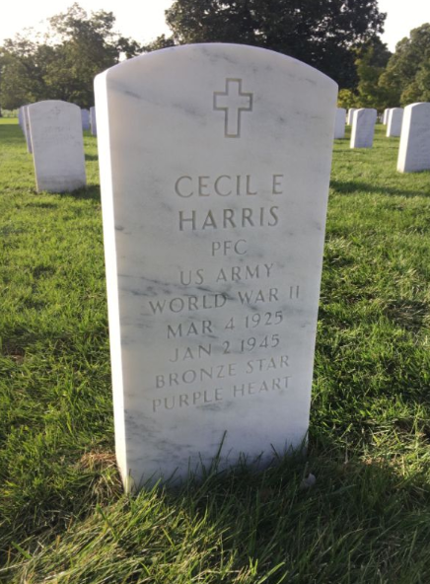

70 Jahre nach seinem Tod wurde ein Soldat aus Tennessee in Arlington begraben

Maria Trojan | Büro in Tennessee in Washington

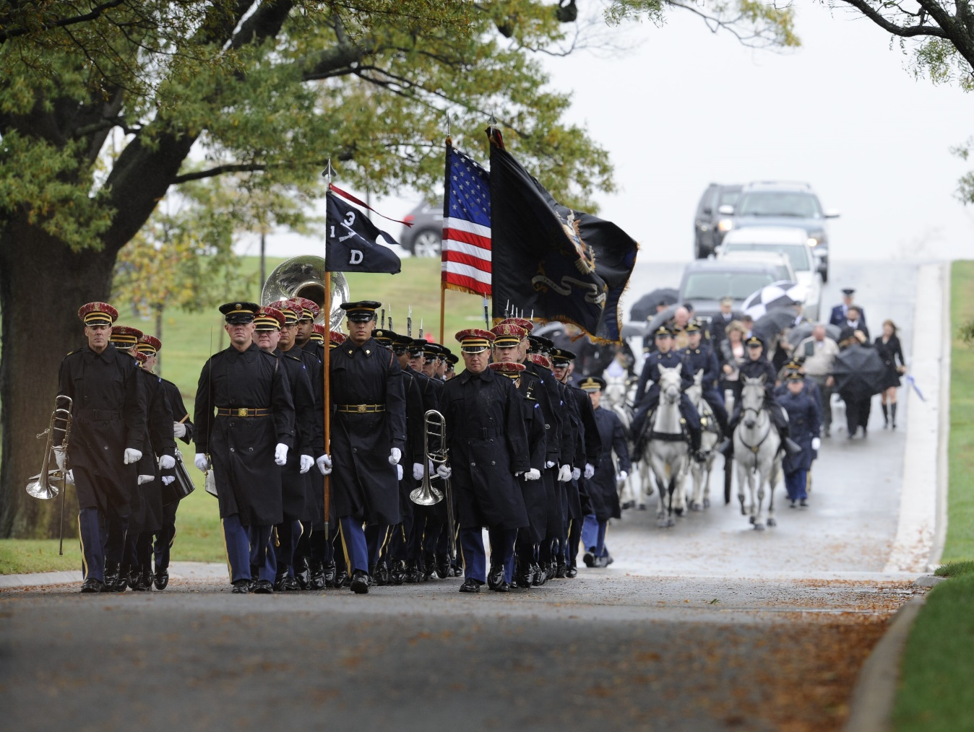
Ansicht |14 Fotos
Veteran des Zweiten Weltkriegs, gefunden in Frankreich, begraben auf dem Nationalfriedhof Arlington

WASHINGTON – Fast 70 Jahre nach seinem Tod im Kampf gegen deutsche Truppen im Nordosten Frankreichs wurde Army Pvt. 1st Class Cecil Harris of Shelbyville am Mittwoch mit allen militärischen Ehren auf dem Nationalfriedhof Arlington beigesetzt.
"Zu Lebzeiten ehrte er die Flagge, und im Tod wird ihn die Flagge ehren", sagte der Kaplan der US-Armee, Captain Ted Randall, während der Trauerfeier.
Harris wurde am 2. Januar 1945 getötet, aber seine sterblichen Überreste wurden erst im vergangenen Jahr von französischen Wanderern gefunden.
Bei kaltem, klatschendem Regen folgten etwa 15 Familienmitglieder aus Tennessee und einige andere dem von Pferden gezogenen Caisson, der Harris' mit einer Flagge geschmückten Sarg den McClellan Drive hinunter zum Friedhof trug, während die U.S. Army Band, bekannt als "Pershing's Own", "Onward Christian Soldiers" spielte.
"Ich bin einfach nur stolz darauf, dass ich ihm folgen durfte, bevor sie ihn in die Ruhestätte brachten", sagte William Edwin "Eddie" Harris, der als Säugling das einzige Mal seinen Vater traf.
Cecil Harris war 19 Jahre alt, als er Shelbyville und seine schwangere Frau Helen verließ, um im Zweiten Weltkrieg zu kämpfen. Helen Harris Cooke, 90, war nicht in der Lage, für die Beerdigung nach Nord-Virginia zu reisen, sagte Eddie Harris. Janice Carlton, die 10 Jahre alt war, als ihr Bruder starb, war am Mittwoch unter den Trauernden.
"Ich bin erleichtert, dass wir ihn zurückbekommen haben und mit Ehren dort begraben haben, wo er es verdient hat", sagte Eddie Harris nach dem Gottesdienst. "Ich habe mich 70 Jahre lang gefragt, was mit ihm passiert ist."
Harris qualifizierte sich für alle militärischen Ehren, eine knackige, würdevolle Zeremonie, die vom 3. US-Infanterieregiment der Armee, bekannt als The Old Guard, durchgeführt wurde. Zu den Diensten gehören ein Senkkasten, ein Begleitzug, ein Farbenteam, ein Sargteam, drei Gewehrsalven eines Schießteams und eine Musikkapelle.
Der Trompeter, Army Staff Sgt. Jeffrey Northman, spielte nach den Bemerkungen des Kaplans "Taps".
"PFC Cecil Edwin Harris hat unserer Nation mit Ehre und Auszeichnung gedient", sagte der Kaplan. "Er hat sich seinen Platz auf diesem heiligen Boden verdient."
Harris war Mitglied des Schützenzuges der Kompanie D, 179. Infanterieregiment, 45. Infanteriedivision. Er erhielt das Combat Infantryman Badge, die European African Middle Eastern Campaign Medal, die World War II Victory Medal, den Bronze Star und das Purple Heart.
Während die Band "America the Beautiful" spielte und der Regen stärker fiel, falteten die Soldaten der Alten Garde die US-Flagge, die den Sarg bedeckt hatte. Die Flagge wurde Eddie Harris von Generalleutnant a.D. Bill Phillips aus Bell Buckle, Tennessee, überreicht, in der Nähe des Ortes, an dem Cecil Harris aufgewachsen ist.
Eddie Harris hat einen Rahmen für die Flagge in seinem Haus in Mountain City, Tennessee, und plant, ihn an die Wand neben seinem Bett zu hängen.
"Ich hätte nie gedacht, dass dieser Tag kommen würde", sagte er.
Kontaktieren Sie Mary Troyan unter mtroyan@usatoday.com

